Introduction to Amazon DynamoDB
Task 1: Create a new table
In this task, you create a new table named Music in DynamoDB. Each table requires a partition key (or a primary key) that is used to partition data across DynamoDB servers. A table can also have a sort key. The combination of a partition key and sort key uniquely identifies each item in a DynamoDB table.
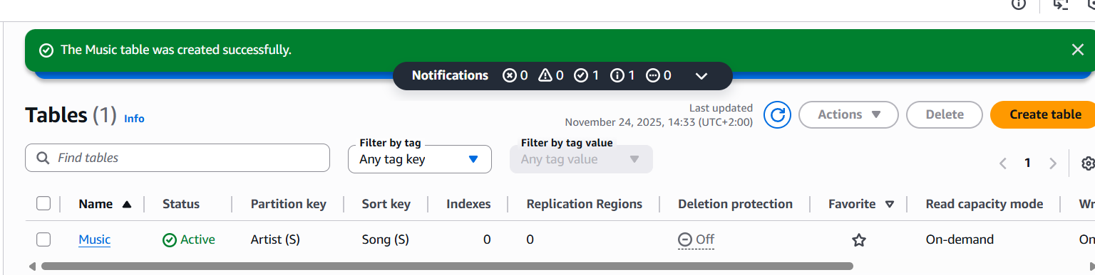
Task 2: Add data

